
Name of Student: Advait Dhanawade | PRN: 25070122023
Subject: Programming with Java
ASSIGNMENT No: 2
TITLE: Develop a Java application demonstrating the use of default, parameterized, and copy constructors for object initialization and data management.

Assignment 2: Methods and Static Members
Problem Statement
Develop a Java application demonstrating the use of default, parameterized, and copy constructors for object initialization and data management.
Learning Objectives
To understand and implement default, parameterized, and copy constructors for object initialization.
Theory
Constructors are special member functions that are automatically invoked when an object is created. Java supports default constructors provided by the compiler, parameterized constructors for initializing objects with user-defined values, and copy constructors (implemented manually) for creating duplicate objects. Constructors improve code readability and simplify object initialization while supporting object-oriented programming principles.
Code
package Assignment2;
class Book {

String title;
String author;
int pages;

//Default Constructor
public Book() {
this.title = "Unknown";
this.author = "Author Unknown";
this.pages = 0;
System.out.println("---Default constructor called.---");

}
//Parameterized Constructor
public Book(String bookTitle, String bookAuthor, int bookPages) {
this.title = bookTitle;
this.author = bookAuthor;
this.pages = bookPages;
System.out.println("---Parameterized constructor called.---");

}
//Copy Constructor
public Book(Book otherBook) {
this.title = otherBook.title;
this.author = otherBook.author;
this.pages = otherBook.pages;
System.out.println("---Copy constructor called.---");
}

public void displayInfo() {
System.out.println("Title: " + title + "\nAuthor: " + author+ "\nPages: " + pages);
System.out.println("============================================");
}
}
class Main {
public static void main(String[] args) {

// using the Default Constructor
Book book1 = new Book();
book1.displayInfo();

//using the Parameterized Constructor
Book book2 = new Book("Kraven's Last Hunt", "J.M. DeMatteis", 168);
book2.displayInfo();

//using the Copy Constructor
Book book3 = new Book(book2);
book3.displayInfo();
}
}

Output
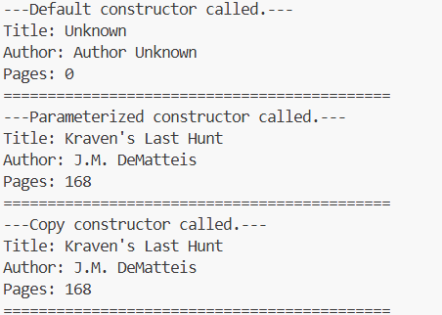

Conclusion: We have successfully implemented default, parameterized, and copy constructors for object initialization and data management in Java.
Exercise
1. Create a Student class using default and parameterized constructors to initialize student name and roll number.
package Assignment2;

//========== Student Record ==========

class Student{
String name;
int rollNo;

Student() { //Default Constructor
name = "Default";
rollNo = 0;
System.out.println("Default Constructor called.");
}

Student(String n, int r) { //Parameterized Constructor
name = n;
rollNo = r;
System.out.println("Parameterized COnstructor called.");
}

void display(){
System.out.println("Name: "+ name + ", Roll No.: " + rollNo);
}
}

public class exercise1{
public static void main(String[] args){
Student student1 = new Student();
student1.display();
Student student2 = new Student("Advait", 23);
student2.display();
}
}

Output
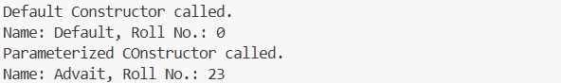

2. Develop a Mobile Phone Inventory System using different constructors to initialize mobile details and create duplicate object records.
package Assignment2;

//========== Mobile Phone Inventory System ==========

class MobilePhone {

String brand;
String model;
double price;

MobilePhone() { //Default Constructor
brand = "Unknown";
model = "Unknown";
price = 0.0;
System.out.println("---Default Constructor called.---");
}

MobilePhone(String b, String m, double p) { //Parameterized Constructor
brand = b;
model = m;
price = p;
System.out.println("---Parameterized Constructor called.---");
}

MobilePhone(MobilePhone otherPhone) { //Copy Constructor
brand = otherPhone.brand;
model = otherPhone.model;
price = otherPhone.price;
System.out.println("---Copy Constructor called.---");
}

void displayDetails() {
System.out.println("Brand: " + brand + " | Model: " + model + " | Price: Rs." + price);
System.out.println("=================================================");
}
}

public class exercise2 {
public static void main(String[] args) {

System.out.println("--- Mobile Phone Inventory System ---\n");

//using the Default Constructor
MobilePhone phone1 = new MobilePhone();
phone1.displayDetails();

//using the Parameterized Constructor
MobilePhone phone2 = new MobilePhone("Samsung", "Galaxy S24", 60000);
phone2.displayDetails();

//using the Copy Constructor
MobilePhone phone3 = new MobilePhone(phone2);
phone3.displayDetails();
}
}

Output
